भारतमौसमविज्ञानविभाग |  | India Meteorological Department
Friday,06th June 2025 (16 Jyeshtha 1947 Saka)
Summary of observations recorded at 0830 hoursIST: The Northern Limit of Monsoon continues to pass through 17.0°N/55°E, 17.5°N/60°E, 18°N/65°E, 18.5°N/70°E, Mumbai, Ahilyanagar, Adilabad, Bhawanipatna, Puri, Sandhead Island, 23.5°N/89.5°E, Balurghat, 30°N/85°E. The trough in middle & upper tropospheric westerlies with its axis at 5.8 km above m. s. l. ran roughly along Long. 83°E to the north of Lat. 20°N. The upper air cyclonic circulation over central Pakistan & adjoining northwest Rajasthan lay over northwest Rajasthan & neighbourhood at 0.9 km above m. s. l. The upper air cyclonic circulation over north interior Karnataka & adjoining Marathwada and Telangana lay over north interior Karnataka & neighbourhood at 3.1 km above m. s. l. A trough runs from south Madhya Maharashtra to Coastal Andhra Pradesh across North Interior Karnataka and Telangana at 1.5 km above mean sea level. An upper air cyclonic circulation lay over northwest Uttar Pradesh & neighbourhood and extended upto 1.5 km above m. s. l. An upper air cyclonic circulation lay over northeast Assam & neighbourhood and extended upto 1.5 km above m. s. l. A fresh western disturbance as a trough in middle tropospheric westerlies with its axis at 5.8 km above m. s. l. ran roughly along Long. 55°E to the north of Lat. 31°N. The trough from south Chhattisgarh to north Bangladesh became less marked. The upper air cyclonic circulation over south Haryana & neighbourhood became less marked. The upper air cyclonic circulation over north Bangladesh & neighbourhood became less marked. The north-south trough ran roughly along Long. 88°E to the north of Lat. 22°N became less marked. The upper air cyclonic circulation over Jharkhand & adjoining south Bihar became less marked at 1730 hours IST of yesterday.

Day temperatures were appreciably above normal(3.1°C to 5.0°C) at few places over Kerala & Mahe; at isolated places over Bihar; above normal(1.6°C to 3.0°C) at many places over Lakshadweep; at few places over Andaman & Nicobar Islands; at isolated places over Assam & Meghalaya, Nagaland, Manipur, Mizoram & Tripura, Gangetic West Bengal, Odisha, East Madhya Pradesh and Saurashtra & Kutch; near normal (-1.5°C to 1.5°C) at many places over West Uttar Pradesh; at most places over Arunachal Pradesh, Sub Himalayan West Bengal & Sikkim, Konkan & Goa, Coastal Andhra Pradesh & Yanam, Tamil Nadu, Puducherry & Karaikal, Coastal Karnataka and South Interior Karnataka; at few places over East Uttar Pradesh, West Rajasthan, Gujarat Region, Madhya Maharashtra, Chhattisgarh and North Interior Karnataka; at isolated places over Uttarakhand, Haryana-Chandigarh-Delhi, Himachal Pradesh, Jammu-Kashmir-Ladakh-Gilgit-Baltistan-Muzaffarabad and West Madhya Pradesh. Yesterday, the highest maximum temperature of 41.8°C was reported at Jaisalmer (West Rajasthan).

The Southwest Monsoon has been subdued over Arunachal Pradesh, coastal Andhra Pradesh, Telangana, Rayalaseema, coastal Karnataka, north interior Karnataka, south interior Karnataka and Kerala.
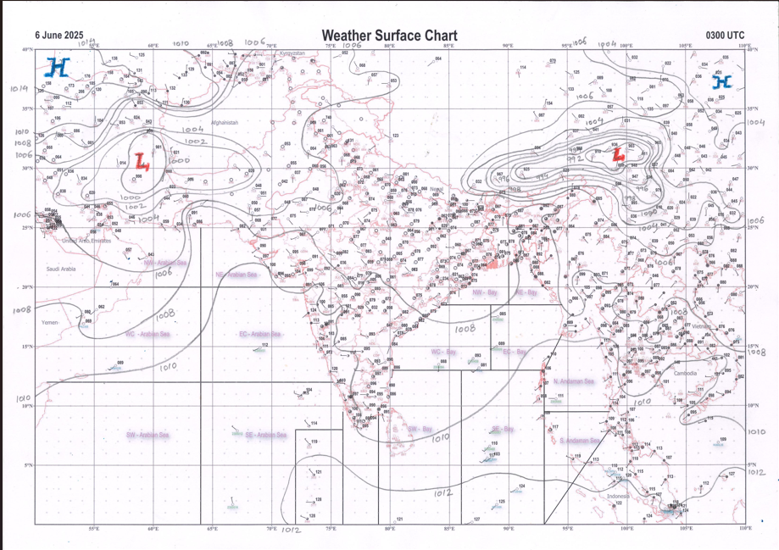 | 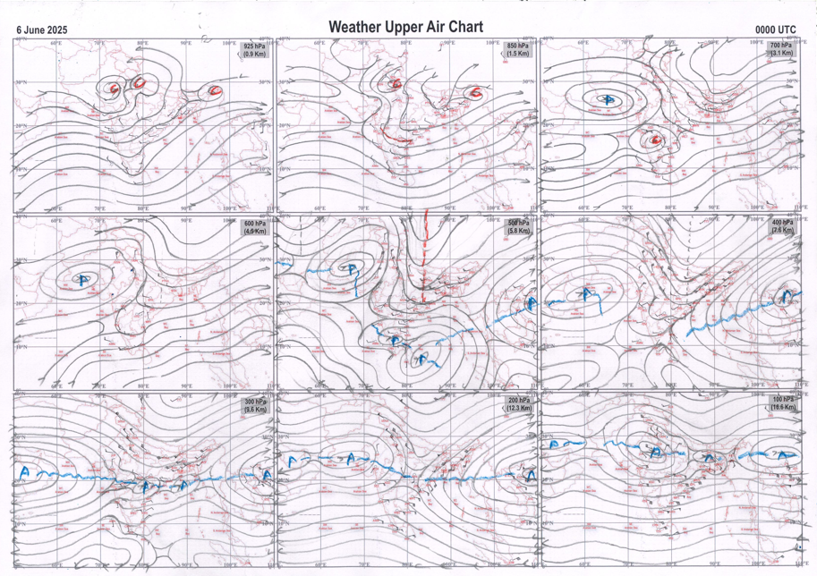
g.1. Analysed surface chart based on 03z observation | Fig.2. Analysed upper air chart based on 00z observation

Dr. S.D.Sanap
Scientist ‘D’
CR & S Office, Pune  Issued at 1245 hrs. IST |  | Weather Forecasting Division  CR&S, Pune

Indian regions | Realised rainfall (chief amount in cm during past 24 hrs):
East | many places: Sub-Himalayan West Bengal & Sikkim+  a few places: Assam & Meghalaya and Nagaland-Manipur-Mizoram-Tripura+  isolated places: Arunachal Pradesh, Gangetic West Bengal, Odisha and Jharkhand  dry weather: Bihar  Kadamtala ARG 10.5, Siliguri PTO 9.7, Zurrantee t.e 9.2, Dm office ARG 7.3, Agartala AP 6.6, Nongstein 6.3, Purushottampur 4.7, Mawsynram 3.4, Talcher 3.2, Dholai 3.0, Amta 2.4, Sagar island PTO 1.7, Bagdogra IAF 1.3, Naharlagun, Dum dum & Gopalpur 1.0 each, Jung ARG 0.8, Pathargama 0.4, Bomdila & Giridih 0.2 each, Na1, Na2 & Na3 NaN each.
North | isolated places: Uttar Pradesh, Uttarakhand, Haryana, Punjab◆, Himachal Pradesh, Jammu-Kashmir and Ladakh◆ and Rajasthan  Kakardharighat 4.9, Thalisain 3.0, Gairsain 2.3, Kanina 2.2, Mussoorie 1.7, Manethi REV 1.5, Chatargarh SR, Ladnoo & Uniara / aligarh 1.0 each, Kurawali 0.9, Patiyali, Alwar obs & Mandawar 0.7 each, Palampur & Nagaur tehsil SR 0.6 each, Ghazipur & Chaupal 0.4 each, Ropar kvk AWS & Manali 0.1 each.
Central | isolated places: Madhya Pradesh, Vidarbha◆ and Chhattisgarh  Nalchha 2.6, Raisen-aws 2.4, Darbha 2.2, Depalpur & Mahasamund 1.9 each, Bajag 1.0, Sirmaur 0.6, Sindewahi 0.1.
Peninsula | a few places: Konkan & Goa  isolated places: Gujarat State, Madhya Maharashtra, Marathwada, coastal Andhra Pradesh, Telangana, Rayalaseema, Tamil Nadu, coastal Karnataka, north interior Karnataka, south interior Karnataka◆ and Kerala  Thane 5.0, Vikramgad 4.2, Targhadia AWS & Trimbakshwar 3.9 each, Kolhapur / Karvir IMD 3.0, Rahuri 2.7, Tbia IMD part time 2.6, Chintapalle 2.3, Kunnamkulam AWS 2.1, Cheepurupalle 2.0, Castle rock & Mattanchery AWS 1.9 each, Kothagudem & Harisan malayalam ltd. 1.7 each, Wood braiyar estate 1.6, Hakimpet IAF & Bellatti 1.5 each, Manchal 1.3, Phulambri, Pathri, Kadra & Athni 1.1 each, Pamidi & Kochi IAF 0.7 each, Dangs (ahwa) 0.6, Dholka ARG 0.5, Parbhani 0.4, Mangaluru AP 0.3, Visakhapatnam, Coonoor & Gadag PBO 0.2 each, Ranpur ARG, Palasamudram, Maddur & Empri 0.1 each.
Islands | isolated places: Andaman & Nicobar  dry weather: Lakshadweep  Long island 0.7, Iaf carnicobar & Hut bay 0.2 each.
Table 2. Forecast / warnings (distribution of rain / thundershowers) for 7 days (valid from time of origin upto 0830 hrs IST of next day)
Sr. No |  | Sub-division Name | Day 1 | Day 2 | Day 3 | Day 4 | Day 5 | Day 6 | Day 7 | Sr. No. | Sub-division Name | Day 1 | Day 2 | Day 3 | Day 4 | Day 5 | Day 6 | Day 7
 |  |  | 06 Jun | 07 Jun | 08 Jun | 09 Jun | 10 Jun | 11 Jun | 12 Jun |  |  | 06 Jun | 07 Jun | 08 Jun | 09 Jun | 10 Jun | 11 Jun | 12 Jun
 | 1 | Andaman Nicobar Islands | W | W | W | W | W | W | F | 19 | west Madhya Pradesh | I | I | I | I+ | I+ | I | I
 | 2 | Arunachal Pradesh | S | S | S | F +  | F +  | F + | F + | 20 | east Madhya Pradesh | I | I | I | I+ | I+ | I | I
 | 3 | Assam-Meghalaya | S | S | S | F +  | W + | W + | W + | 21 | Gujarat region | I | I | I | I | I | I | I
 | 4 | Nagaland-Manipur-Mizoram-Tripura | W +  | W +  | W | W + | F+  | F + | F | 22 | Saurashtra and Kutch | I | I | I | I | I | I | I
 | 5 | Sub Himalayan West Bengal/Sikkim | F | S | S | S | S | S | S | 23 | Konkan and Goa | S | S | S | S | S | S | F
 | 6 | Gangetic West Bengal | S | I | I | I | I | S | S | 24 | Madhya Maharashtra | S | S +  | S | I | I | I | I
 | 7 | Odisha | I+ | I+ | I+ | I+ | I+ | I | I | 25 | Marathwada | I | S +  | S | I | I | I | I
 | 8 | Jharkhand | I | I | I | I | S | S | S | 26 | Vidarbha | I | I | I | I | I | I | I
 | 9 | Bihar | I | I | I | I | S | S | S | 27 | Chhattisgarh | I | I | I | I | I | I | I
 | 10 | east Uttar Pradesh | D | D | D | D+ | D+ | I | I | 28 | Coastal Andhra Pradesh and Yanam | I+ | I+ | I+ | I | S | S + | F +
 | 11 | west Uttar Pradesh | D | D | D | D+ | D+ | D | D | 29 | Telangana | I | I | S | S | S | S | S
 | 12 | Uttarakhand | I | D | D | D | D | I | I | 30 | Rayalaseema | I | I | I | S | S | F + | F +
 | 13 | Haryana,Chandigarh and Delhi | D | D | D | D+ | D+ | D | D | 31 | Tamil Nadu, Puducherry and Karaikal | I+ | I+ | I+ | S | S +  | S + | S +
 | 14 | Punjab | D | D | D | D+ | D+ | D | D | 32 | Coastal Karnataka | I | S | S | F | W | F | W +
 | 15 | Himachal Pradesh | I | D | D | D | D | I | I | 33 | North interior Karnataka | I | S | S | F | F | F | F +
 | 16 | Jammu-Kashmir and Ladakh | D | D | D | D | I | I | I | 34 | South interior Karnataka | I | I | S | F | F | F + | F +
 | 17 | west Rajasthan | D | D | D+ | D+ | D+ | D | D | 35 | Kerala and Mahe | S | S | S | F | W + | W + | W +
 | 18 | east Rajasthan | I | I | I | D | D | D | D | 36 | Lakshadweep | S | S | S | F | W | W | W
Legends: D = DryI = IsolatedS = ScatteredF = Fairly widespreadW = Widespread #= heavy to very heavy rain at a few places with extremely heavy rain at isolated places +++= heavy rain at a few places with very heavy rain at Isolated places ++= heavy to very heavy rainfall @=Isolated exceptionally heavy rainfall + = heavy rain ●/*= rain or snow ♦ = very light rain ≡=fog= thunderstorm with lightning =Squall / Gusty / gale / strong wind ­ =cold wave/cold day += heat wave/warm night/hot and humid weathe r=Duststorm =ground frost = Hail

Fig. 4: Districtwise warnings for five days for Maharashtra State
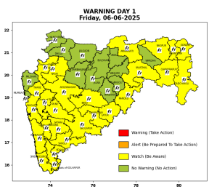 | 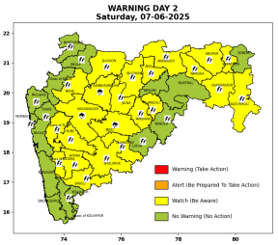 | 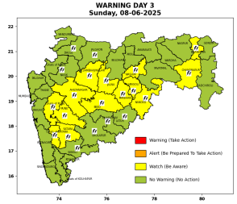 | 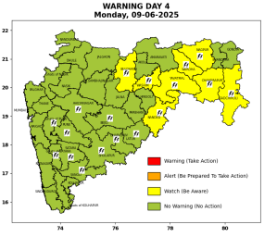 | 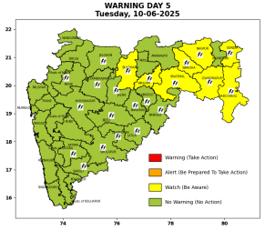

Pune, Lohegaon and Pashan observations at 0830 hrs. IST of Today
 | Temperature (°C) |  |  |  |  | Humidity (%) |  |  |  | Rainfall (mm)
 | Max.  past  24 hrs | Dep.  from  normal | Min.  past  24 hrs. | Dep.  from  normal | Dry  Bulb | At 0830 hrs. IST | Dep.  From  normal | At 1730  hrs. IST of y’day | Dep.  from  normal | Past  24 hrs. | Since  1st June | Dep.  from  normal
PNE | 32.0 | -2.3 | 23.6 | 0.2 | 26.6 | 79 | 6 | 72 | 14 | 0.0 | 17.9 | -9.7
PSN | 30.2 | - | 22.1 | - | 25.8 | 83 | - | 74 | - | 3.4 | 20.3 | -
LHG | 34.5 | 1.5 | 25.6 | 4.6 | 28.5 | 55 | -17 | 56 | 1 | 0.0 | 14.0 | -1.34

 |  |  |  |  |  |  | Local (Pune and neighbourhood) forecast
Max./Min. Temperature (°C) |  |  |  |  |  |  |  |  | Weather
Date | Pune | Pashan | Lohegaon | Chinchwad | Lavale | Magarpatta | NDA | Koregoan Park
06/06/25 | 33/23.6* | 33/22.1* | 35/25.6* | 32/24.1* | 30/- | 33/25.2* | 31/22.9* | 33/25.4* | Partly cloudy sky becoming generally cloudy sky towards afternoon/evening. Thunderstorm with lightning, light to moderate rain very likely.
07/06/25 | 32/24 | 32/23 | 34/26 | 32/24 | 29/23 | 32/25 | 30/23 | 32/25 | Partly cloudy sky becoming generally cloudy sky towards afternoon/evening. Thunderstorm with lightning, light to moderate rain very likely.
08/06/25 | 32/23 | 32/22 | 34/25 | 32/23 | 29/22 | 32/24 | 30/22 | 32/24 | Partly cloudy sky becoming generally cloudy sky towards afternoon/evening. Thunderstorm with lightning, light rain very likely.
09/06/25 | 33/23 | 33/22 | 35/25 | 33/23 | 30/22 | 33/24 | 31/22 | 33/24 | Partly cloudy sky becoming generally cloudy sky towards afternoon/evening. light rain very likely.
10/06/25 | 33/24 | 33/23 | 35/26 | 33/24 | 30/23 | 33/25 | 31/23 | 33/25 | Partly cloudy sky becoming generally cloudy sky towards afternoon/evening. light rain likely.
11/06/25 | 33/24 | 33/23 | 35/26 | 33/24 | 30/23 | 33/25 | 31/23 | 33/25 | Partly cloudy sky becoming generally cloudy sky towards afternoon/evening. light rain likely.
12/06/25 | 32/24 | 32/23 | 34/26 | 32/24 | 29/23 | 32/25 | 30/23 | 32/25 | Partly cloudy sky becoming generally cloudy sky towards afternoon/evening. light rain likely.
Rainfall Distribution |  |  | Rainfall Categories | Rainfall (mm) |  | Cloud condition |  |  |  | Rainfall Intensity |  | Range
Widespread (W) | 76-100% |  | Very Light rain | Trace to 2.4 mm |  | Mainly clear sky |  | 1-2 oktas |  | Light Spell |  | 1 cm/hr
 |  |  | Light rain | 2.5 to 15.5 mm |  | Partly cloudy sky |  | 3-4 oktas |  | Moderate Spell |  | 1-2 cm/hr
Fairly Widespread (FW) | 51 – 75% |  | Moderate rain | 15.6 to 64.4 mm |  | Generally cloudy sky |  | 5-7 oktas |  | Intense Spell |  | 2-3 cm/hr
Scattered (S) | 26 – 50% |  | Heavy rain | 64.5 to 115.5 mm |  | Overcast |  | 8 oktas |  | Very Intense Spell |  | 3-5 cm/hr
isolated (I) | 1 – 25% |  | Very heavy rain | 115.6 to 204.4 mm |  |  |  |  |  | Extremely Intense Spell |  | 5-10 cm/hr
D (D) | No Rain |  | Extremely heavy rain | ≥ 204.5 mm |  |  |  |  |  | Cloudburst |  | > 10 cm/hr
Probability Terms in %: |  |  | Heavy snow | 6.5 to 11.5 cms water equivalent of rain
unlikely | < 25 |  | Very heavy snow | 11.6 to 20.4 cms water equivalent of rain
likely | between 25 50
very likely | between 51 75
most likely | >75
* = realized temperature
Mumbai (Colaba) |  |  |  | Nagpur (AP)
Date 2025 | T max °C | T min °C | Weather | T max °C | T min °C | Weather
06/06 | 33 | 26 | Partly cloudy sky with possibility of moderate rain or Thunderstorm. Thunderstorm accompanied with lightning & gusty winds(30-40kmph). | 42 | 27 | Rain or thundershowers with strong gusty winds.
07/06 | 33 | 26 | Partly cloudy sky with one or two spells of rain or thundershowers. | 39 | 29 | Rain or Thunderstorm accompanied with lightning & gusty winds(30-40kmph).
08/06 | 32 | 26 | Generally cloudy sky with light rain. | 39 | 28 | Rain or Thunderstorm accompanied with lightning & gusty winds(40-50kmph).
09/06 | 32 | 27 | Generally cloudy sky with light rain. | 38 | 28 | Partly cloudy sky towards afternoon or evening.
10/06 | 32 | 27 | Generally cloudy sky with light rain. | 40 | 28 | Partly cloudy sky towards afternoon or evening.
11/06 | 32 | 27 | Rain. | 40 | 28 | Partly cloudy sky with possibility of rain or Thunderstorm.
12/06 | 32 | 27 | Rain. | 40 | 28 | Partly cloudy sky with possibility of rain or Thunderstorm.

